**Topics: Descriptive Statistics and Probability**

1. Look at the data given below. Plot the data, find the outliers and find out $μ, σ, σ^{2}$

|  |  |
| --- | --- |
| **Name of company** | **Measure X** |
| Allied Signal | 24.23% |
| Bankers Trust | 25.53% |
| General Mills | 25.41% |
| ITT Industries | 24.14% |
| J.P.Morgan & Co. | 29.62% |
| Lehman Brothers | 28.25% |
| Marriott | 25.81% |
| MCI | 24.39% |
| Merrill Lynch | 40.26% |
| Microsoft | 32.95% |
| Morgan Stanley | 91.36% |
| Sun Microsystems | 25.99% |
| Travelers | 39.42% |
| US Airways | 26.71% |
| Warner-Lambert | 35.00% |

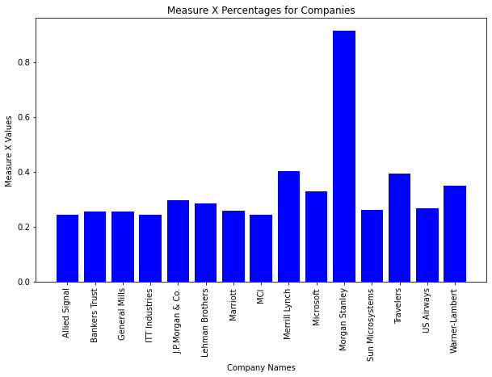

Mean (μ): 0.3327133333333333

Standard Deviation (σ): 0.16370812590976933

Variance (σ^2): 0.026800350488888885



Answer the following three questions based on the box-plot above.

1. What is inter-quartile range of this dataset? (please approximate the numbers) In one line, explain what this value implies.

Ans:-

IQR = Q3 -Q1=12.5-5=7.5

This value implies that the IQR is calculated as the difference between the third quartile (Q3) and the first quartile (Q1). Mathematically, IQR = Q3 - Q1.

1. What can we say about the skewness of this dataset?

Ans:-

By viewing the above boxplot dataset we can say that the skewness of this dataset is positively skewed

1. If it was found that the data point with the value 25 is actually 2.5, how would the new box-plot be affected?

Ans:-

If you change the outlier from 25 to 2.5, it is now much closer to the rest of the data.The IQR would likely be affected, and the whiskers might not extend far enough to include the new outlier.The boxplot would visually change, potentially with a shorter whisker length or no outliers displayed.



Answer the following three questions based on the histogram above.

1. Where would the mode of this dataset lie?

Ans:-

The mode of this dataset lies between the frequency of 5 to 10

1. Comment on the skewness of the dataset.

Ans:-

The skewness of the dataset is positive

1. Suppose that the above histogram and the box-plot in question 2 are plotted for the same dataset. Explain how these graphs complement each other in providing information about any dataset.

Ans:-

Suppose the above histogram and boxplot have same dataset they will represent the same skewness and also same outliers

1. AT&T was running commercials in 1990 aimed at luring back customers who had switched to one of the other long-distance phone service providers. One such commercial shows a businessman trying to reach Phoenix and mistakenly getting Fiji, where a half-naked native on a beach responds incomprehensibly in Polynesian. When asked about this advertisement, AT&T admitted that the portrayed incident did not actually take place but added that this was an enactment of something that “could happen.” Suppose that one in 200 long-distance telephone calls is misdirected. What is the probability that at least one in five attempted telephone calls reaches the wrong number? (Assume independence of attempts.)

Ans:-

CODE

def probability_of_misdirection(prob_single_attempt, num_attempts):

prob_none_wrong = (1 - prob_single_attempt) ** num_attempts

prob_at_least_one_wrong = 1 - prob_none_wrong

return prob_at_least_one_wrong

prob_single_attempt = 1 / 200

num_attempts = 5

result_probability = probability_of_misdirection(prob_single_attempt, num_attempts)

print(f"The probability that at least one in {num_attempts} attempts reaches the wrong number is: {result_probability:.5f}")

The probability that at least one in 5 attempts reaches the wrong number is: 0.02475

1. Returns on a certain business venture, to the nearest $1,000, are known to follow the following probability distribution

|  |  |
| --- | --- |
| x | P(x) |
| -2,000 | 0.1 |
| -1,000 | 0.1 |
| 0 | 0.2 |
| 1000 | 0.2 |
| 2000 | 0.3 |
| 3000 | 0.1 |

1. What is the most likely monetary outcome of the business venture?

Ans:-

The most likely monetary outcome of the business venture is $1000

1. Is the venture likely to be successful? Explain

Ans:-

The individual outcomes can still vary so the venture may not always be successful in every instance

1. What is the long-term average earning of business ventures of this kind? Explain

Ans:-

The long-term average earnings of business ventures of this kind are $500. This means that, on average, the venture is expected to earn $500 over the long run for each business venture of this type.

1. What is the good measure of the risk involved in a venture of this kind? Compute this measure

Ans:-

The standard deviation of this probability distribution is approximately $2181.45. This standard deviation provides a measure of the risk involved in the venture, indicating the degree of variability or uncertainty in the potential outcomes.